The Advisor
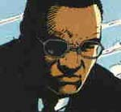
Real Name: Unknown
First Appearance: War Machine 1
What's His Problem? He seems to have a big problem understanding such things as freedom, rights of individuals, and peace in general. He does believe however, that slaughter (preferrably of innocents) is needed to makes himself all the more powerful. He's claimed to have masters for whom he is trying to "restore the natural order of things," not that he needs the help. His power grows with every futile death and senseless act of violence so he certainly wants to promote such acts. And frankly, he just plain enjoys it all.
Abilities: Besides being a first class manipulator? Well, he's shown the ability to stand up to War Machine's repulsor blasts (which could easily level a large building), phased, played with fire and astral projection. He rarely seems to involve himself personally but he did demonstrate the ability to use a machine gun with some skill.
Weapons: I'm afraid that to the Advisor, people themselves are his weapons.
Favorite Quote: His talk with Vincent Cetawayo, a noted humanitarian, shortly before the Advisor killed him in War Machine 4 is unforgettable as it shows his true malicious nature: "We're doing more than killing you... We're going to negate you."
Heroes He Keeps Running Into: While he started out at odds with War Machine, he's also had to deal with the likes of Deathlok, Cable, Hawkeye and USAgent. Each and everyone of them was somehow drawn in by his plotting.
People Who Think He's Not So Bad: No doubt the Advisor makes friends with many of the people he helps establish in power (like former military dictator Eda Arul) but it's inevitable that he'll turn on them to cause more death and mayhem.
Most Despicable Act: Organizing the destruction of an entire country just to mimimize the impact of the murder of one lone humanitarian strikes me as being pretty blatantly despicable. And let's not forget he's alleged that he was involved in any number of other catastrophes.
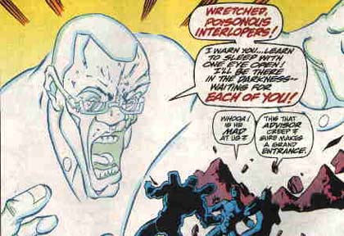

Blacklash
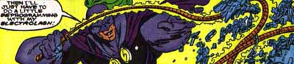
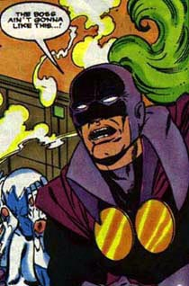
Real Name: Mark Scarlotti, although he's also been called Mark Scott
AKA: Whiplash. He changed his codename in Iron Man 146 when he upgraded his arsenal to include a bullet-resistant mesh cloak, a concussive charge in his whip handle, and a number of other cute tricks. He also dyed the plume in his helmet green instead of orange. (I don't know why a super-villain feels the need to wear a plume in his cowl, but I like the look!)
First Appearance: Tales of Suspense 97
What's His Problem? When in costume, Blacklash is pretty much a sadistic jerk that likes to bully other people. Out of costume, he's a manic depressive who wishes he had his costume on so he could bully other people. Formerly one of Stark's research heads, Scarlotti became entangled with the Maggia. Accepting Maggia money for his research, he constructed a unique metallic whip that is stronger than most other metals with the probable exception of adamantium. Since Iron Man doesn't use adamantium in his armor, Blacklash has been able to give him some serious trouble over the years.
Abilities: As seems to be the case with most of Stark's research heads, Blacklash is a high-caliber, well-trained athlete with excellent hand-to-hand combat skills as well as being an engineer and research scientist of some note. Where does Stark find these guys? More importantly, why do they keep turning against him?
Heroes He Keeps Running Into: Blacklash's long term employment by Justin Hammer means he can be thrown against Iron Man at a minute's notice. He has also gone up against Spider-Man, the New Warriors, Silver Sable's Wild Pack, and is willing to attack anyone else Hammer tells him to attack.
Favorite Quote, Whiplash: "You are speaking to an artist, slug! A master of the multi-powered lash! I will do what must be done...when the proper moment is at hand! Destroying one's nemesis must be an act of inspiration!" (Marvel Team Up 72, when an unusually poetic Whiplash refused to destroy Spider-Man out of hand. He regretted it later. Big time.)
Favorite Quote, Blacklash: "You are one sick puppy! But if it's pain you crave--" (Silver Sable and the Wild Pack 22, where an astonished Blacklash meets up with Crippler, a Wild Pack member so depraved it gives even a super-villain with an electric lash pause. No truth to the rumor that Crippler asked for one of Blacklash's whips as a memento, and even less that he got Blacklash's phone number...)
People Who Think He's Not So Bad: After being thrown out of the Maggia, Scarlotti went to work for Justin Hammer. Blacklash is oddly devoted to Hammer, who, despite considering the villain to be among the top echelon of his super-powered employees, would drop Scarlotti in a heartbeat if it were just slightly convenient. He has one high school buddy, Rusty, who hasn't entirely given up on him (unlike Scarlotti's own parents, who have completely disowned him). He has teamed up numerous times with other Hammer employees such as Blizzard, Boomerang, the Beetle, and the Melter. The recent murder of his wife, Trudi (Elektra 7) seems to have finally given Mark pause; with a child to raise on his own, Blacklash is re-thinking his life, and may either retire or switch sides.
Most Despicable Act: No one is safe from Blacklash, not even domesticated animals. In Iron Man 146, Blacklash crushed the pet dog of Stark security guard Vic Martinelli when it got in his way (although, in the bad guy's defense, he didn't know there was a dog behind the wall he knocked over). As Sean McQuaid recalls it: "Sure, it's not a loss of human life, but I wanted to reach into the comic and strangle the scuzzball regardless. It's one of those nasty comic book moments that made me really angry." Personally, I always think it's the writer who came up with the let's-kill-a-small-animal-as-a-plot-device idea that should pay some sort of penalty.
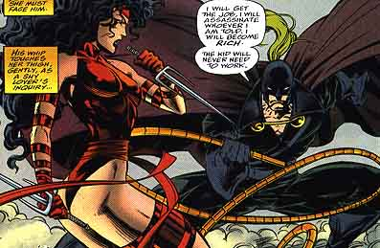

Blizzard
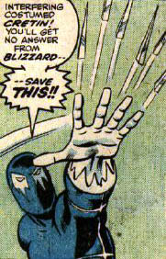
Real Name: Gregor Shapanka.
AKA: Jack Frost
First appearance: As Jack Frost II, Tales of Suspense 45; as Blizzard, Iron Man 86.
Died in: Amazing Spider-Man Annual 20.
What's His Problem? A brilliant scientist, Gregor Shapanka was a greedy, ambitious man who envied the success of his employer, millionaire playboy inventor Anthony Stark (secretly Iron Man, Stark's supposed bodyguard). Fired for stealing from Stark but spared criminal charges out of respect for his achievements, Shapanka struck back using his unique refrigeration devices to attack Stark as the super-criminal Jack Frost. Years later, Shapanka further refined his refrigeration technology and assumed a new, deadlier criminal guise as The Blizzard.
Abilities: Shapanka turned his scientific and engineering genius toward exploring alternative uses for advanced refrigeration technology, eventually designing and constructing his Blizzard battle suit. For a time, Shapanka was able to manifest his Blizzard powers without his armor after an accident changed him into a sort of ice creature, but he later regained his human form and lost those powers through unrevealed means.
Weapons: Shapanka's Blizzard costume contains miniature refrigeration units capable of draining heat from the surrounding area almost instantaneously, creating freezing temperatures that can incapacitate normal, unshielded individuals. The costume's insulation protected Shapanka himself from the adverse effects of extreme cold.
Favorite quote: "By providing myself with a coating of ice armor--I may yet prove triumphant!" Iron Man 124. The preceding quote was one of Blizzard's wonkier ideas, and worked about as well as you'd think: in a contest of ice versus electromagnetically reinforced iron, Blizzard didn't stand a snowball's chance (never mind how he mustered the strength or mobility for fisticuffs from inside a super-thick bodily shell of solid ice; but I digress...)
Heroes He Kept Running Into: Shapanka battled Spider-Man twice and also ran afoul of Daredevil and the Hulk, but his eternal nemesis was Iron Man. Though he got his licks in (and darn near killed Iron Man in his first outing as Blizzard), Shapanka was trounced by Stark ad nauseam, climaxing in Shapanka's unfortunate encounter with the alternate future Iron Man of 2020. Blizzard attacked, believing IM 2020 to be his old foe, and the no-nonsense future Iron Man blasted him dead on the spot. A sadly senseless demise for one of Marvel's veteran villains; the dying Shapanka should have at least been given the chance to utter those immortal lines, "I'm melting...melting!....all my beautiful evil...What a world, what a world..." (Editorial note: Sean neglects to mention that Blizzard got whacked right when he got a truly spiffy new costume, after a decade or so in the classic blue-with-icicle-trimming get-up. The cold, inhuman waste of it all...)
People Who Think He's Not So Bad: Truth to tell, Blizzard was a cold-blooded, egomaniacal creep. He had business associates, like his sometime employer, Justin Hammer, and occasional partners like Electro and the Melter, but he wasn't the sorta fella folks (ahem!) warmed up to.
Most Despicable Act: Viciously assaulting Iron Man and leaving him for dead in Iron Man 86-87. Ol' Shellhead barely escaped with his life.
What's The Blizzard Been Up To Since His Death? Uniquely for Marvel, Shapanka remains quite deceased. However, the costume lives on. It's since been used by two small-time thugs, neither of whom was in Shapanka's league in terms of either skill or sangfroid. They'd both ditched the suit at last report, and Tony Stark (perhaps hoping to succeed with them where he failed with Shapanka) had taken a reformatory interest in both men before his own death.
